Dsm-Dev 19-01-2026 MANUAL

Introduction:

As part of the quality assurance process, a manual audit has been initiated to validate the results generated by the automated vulnerability scanning tools. Each finding is being reviewed to determine its accuracy and relevance, with the objective of classifying them as either true positives (valid security issues) or false positives (non-exploitable or misidentified issues).
This step ensures the reliability of the final report by eliminating noise from automated tools and confirming the presence and impact of vulnerabilities through manual testing techniques. The scan is done twice a month

Table of Contents
Introduction: 2
Dsm-Dev 19-01-2026 Manual 3
Executive Summary 3
SQL Injection 4
Client-Side JSON Injection (DOM-Based) 6
Cookie Manipulation (DOM Based) 9
External DNS Interaction 10
Input Returned in Response (reflected) 12
Browser cross-site scripting filter disabled 14
HTML5 storage manipulation (DOM- based) 15
TLS Certificate 18

Dsm-Dev 19-01-2026 Manual

Executive Summary
The chart below shows the aggregated numbers of issues identified in each category for the automated Done on 05-01--2026. Solid colored bars represent issues with a confidence level of Certain, and the bars fade as the confidence level falls

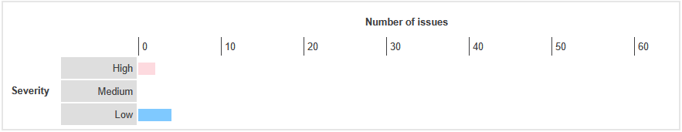

SQL Injection
Severity | High
Finding Type | False Positive

Description
SQL injection vulnerabilities arise when user-controllable data is incorporated into database SQL queries in an unsafe manner. An attacker can supply crafted input to break out of the data context in which their input appears and interfere with the structure of the surrounding query.
A wide range of damaging attacks can often be delivered via SQL injection, including reading or modifying critical application data, interfering with application logic, escalating privileges within the database and taking control of the database server.
Links Tested
- /api/v1/stats/sla-summary [endDate parameter]
- /api/v1/stats/sla-summary [startDate parameter]
Steps
- Login into dsm-dev.zalaris.com
- Crawl the application and capture the request reported with SQL injection
- Forward the request to Intruder add a placeholder value payload injection area
- Start the attack and analyze the response , no SQL injection related information is received
- Refer Screenshot for evidence
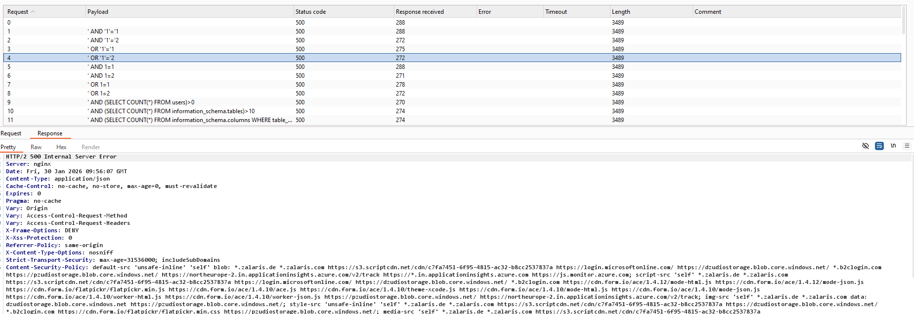

The server returns 500 Internal Server Error and does not give any information related to SQL injection. Alert is False positive

WORKLOG

When | What | Who | Recommended Action
22 January 2026 | Manually Tested the SQL Injection alert | CSOC | No Action Needed the alert is false positive

Client-Side JSON Injection (DOM-Based)

Severity | Low
Finding Type | Informational

Description
DOM-based vulnerabilities arise when a client-side script reads data from a controllable part of the DOM (for example, the URL) and processes this data in an unsafe way.
DOM-based JSON injection arises when a script incorporates controllable data into a string that is parsed as a JSON data structure and then processed by the application. An attacker may be able to use this behavior to construct a URL that, if visited by another application user, will cause arbitrary JSON data to be processed. Depending on the purpose for which this data is used, it may be possible to subvert the application's logic, or cause unintended actions on behalf of the user.
Burp Suite automatically identifies this issue using dynamic and static code analysis. Static analysis can lead to false positives that are not actually exploitable. If Burp Scanner has not provided any evidence resulting from dynamic analysis, you should review the relevant code and execution paths to determine whether this vulnerability is indeed present, or whether mitigations are in place that would prevent exploitation.

Links Tested
- /777/invoices
- /777/statistics
Details

- The reported Issues was - Data is read from document.cookie and passed to JSON.parse
- The following value was injected into the source:
- o8w26kd4a9%2527%2522`'"/o8w26kd4a9/><o8w26kd4a9/\>k6aabixnil&
- The previous value reached the sink as:
- o8w26kd4a9%27%22`'"/o8w26kd4a9/><o8w26kd4a9/\>k6aabixnil&

Steps

- The reported issue is that the application reads input from document.cookie and passed it to JSON.Parse
- Verify that the application reads document.cookie and passes it to JSON Parse
- This can be done by a small monkey patch

const originalParse = JSON.parse;
JSON.parse = function(input) {
console.log("[JSON.parse CALLED WITH]:", input);
return originalParse.call(this, input);
};

- Reload the page
- JSON Parse is calling the cookie value

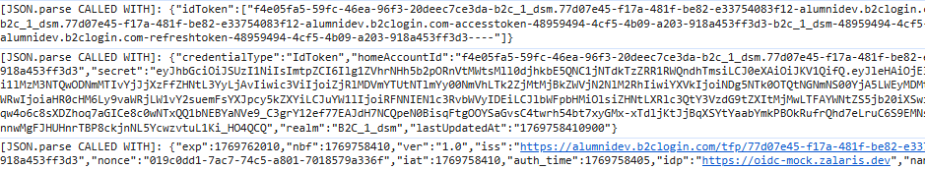

- Login to Dsm-dev.zalaris.com
- In console give the payload document.cookie = "domtest=<img src=x onerror=console.log('DOM_XSS_FIRE')>; path=/";
- Reload Page observe console for XSS
- No XSS is received for the application
- Here is an automated script that be used to test the same

// Automated DOM XSS detection
document.cookie = "domtest=<img src=x onerror=console.log('DOM_XSS_FIRE')>; path=/";

setTimeout(() => {
let fired = false;

const log = console.log;
console.log = function (...args) {
if (args.includes("DOM_XSS_FIRE")) {
fired = true;
}
log.apply(console, args);
};

setTimeout(() => {
if (fired) {
console.error(" DOM XSS CONFIRMED – Payload executed!");
} else {
console.warn(" Reflective HTML found, but payload NOT executed (may be sanitized).");
}
}, 1500);

}, 300);

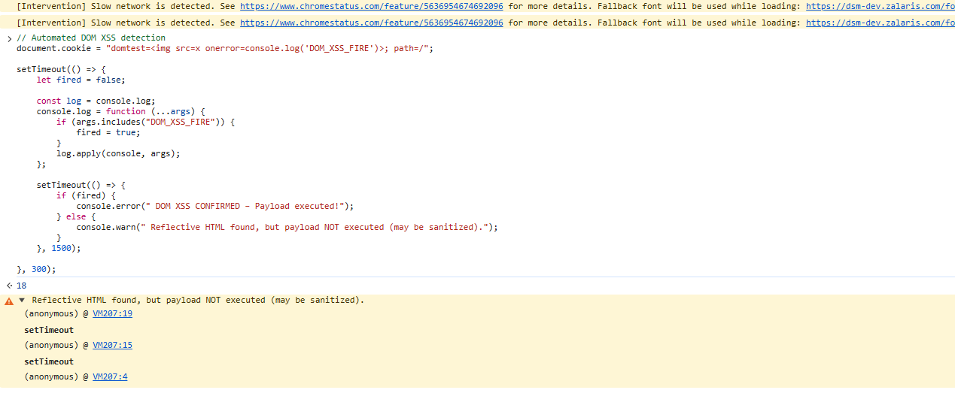

- When the script is run the console confirms that reflective HTML is found but is not executed
- The alert is false positive

WORKLOG
When | What | Who | Recommended Action
22 January 2026 | Manually tested client-side JSON injection (DOM based) | CSOC | No action needed the alert is false positive

Cookie Manipulation (DOM Based)

Severity | Low
Finding Type | False Positive

Description

DOM-based vulnerabilities arise when a client-side script reads data from a controllable part of the DOM (for example, the URL) and processes this data in an unsafe way.
DOM-based cookie manipulation arises when a script writes controllable data into the value of a cookie. An attacker may be able to use the vulnerability to construct a URL that, if visited by another application user, will set an arbitrary value in the user's cookie.
The potential impact of the vulnerability depends on the role that the cookie plays within the application. If the cookie is used to control the behavior that results from certain user actions (for example, a 'production' versus 'demo' mode setting), then the attacker may be able to cause the user to perform unintended actions by manipulating the cookie's value. If the cookie is used to track the user's session, then the attacker may be able to perform a session fixation attack, in which they set the cookie's value to a valid token that they have obtained from the application, and then hijack the session during the victim user's subsequent interaction with the application.
Burp Suite automatically identifies this issue using dynamic and static code analysis. Static analysis can lead to false positives that are not actually exploitable. If Burp Scanner has not provided any evidence resulting from dynamic analysis, you should review the relevant code and execution paths to determine whether this vulnerability is indeed present, or whether mitigations are in place that would prevent exploitation.

Links Reported
- Invoices
- Statistics
Details
- No user-controlled parameter is available to alter the cookie in dsm-dev.zalaris.com
- The alert is considered as false positive
WORKLOG
When | What | Who | Recommended Action
22 January 2026 | Manually Tested Cookie manipulation (DOM Based) | CSOC | No Action Needed the alert is false positive

External DNS Interaction
Severity | Information
Finding Type | False positive

Description

It is possible to induce the application to perform server-side DNS lookups of arbitrary domain names.
The payload z44im7gf5nljnevt5d9do3gtdkjd73vwukk7avz.oastify.com was submitted in the SSL SNI value and the HTTP Host header.
The application performed a DNS lookup of the specified domain.

The ability to induce an application to interact with an arbitrary external service, such as a web or mail server, does not constitute a vulnerability in its own right. This might even be the intended behavior of the application. However, in some cases, it can indicate a vulnerability with serious consequences.
If you can trigger DNS-based interactions, it is normally possible to trigger interactions using other service types. Burp Scanner reports these as separate issues. You may find that a payload, such as a URL, only triggers a DNS-based interaction, even though you were expecting interactions with a different service as well. This could be due to egress filters on the network layer that prevent the application from connecting to these other services. However, some systems perform DNS lookups without any intention of connecting to the remote host. This behavior is typically harmless.
The ability to send requests to other systems can allow the vulnerable server to be used as an attack proxy. By submitting suitable payloads, an attacker can cause the application server to attack other systems that it can interact with. This may include public third-party systems, internal systems within the same organization, or services available on the local loopback adapter of the application server itself. Depending on the network architecture, this may expose highly vulnerable internal services that are not otherwise accessible to external attackers.

Links Tested
- /
Details

The endpoint accessed by the user is under different host-name and the application is not interacting with other hosts

Refer screenshot attached below for evidence

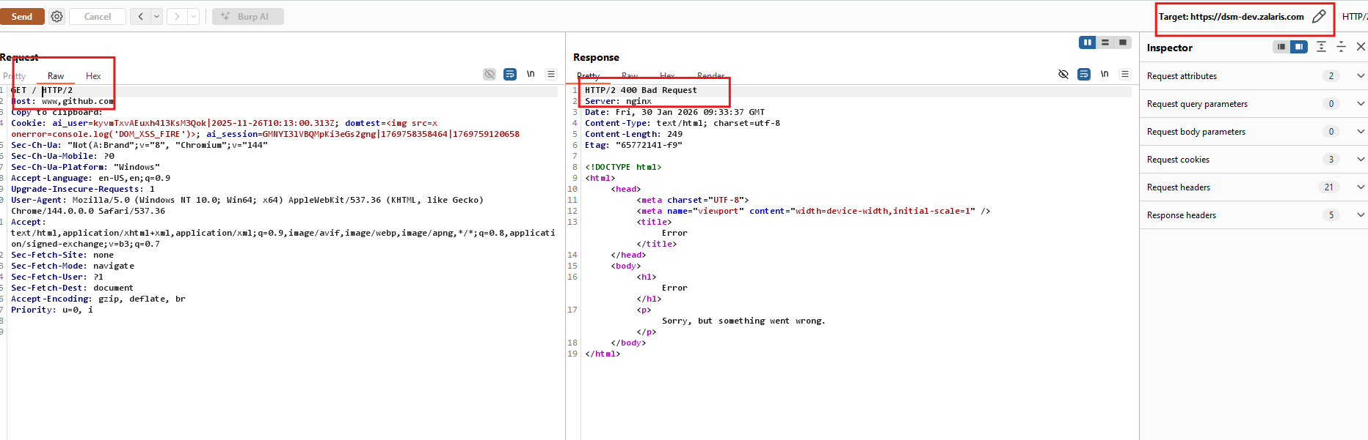

WORKLOG

When | What | Who | Recommended Action
2 January 2026 | Manually tested the alert external DNS Interaction | CSOC | No action Needed the alert is considered as false positive

Input Returned in Response (reflected)

Severity | Information
Finding Type | Informational

Links Reported
- /api/v1/dash/news [URL path folder 3]
- /api/v1/dash/news/670509dee31630728bc84a22 [URL path folder 3]
- /api/v1/org/clients/230/regions/no/contact-book [URL path filename]
- /api/v1/org/clients/230/regions/no/contact-book [URL path folder 1]
- /api/v1/org/clients/230/regions/no/contact-book [URL path folder 2]
- /api/v1/org/clients/230/regions/no/contact-book [URL path folder 3]
- /api/v1/org/clients/230/regions/no/contact-book [URL path folder 4]
- /api/v1/org/clients/230/regions/no/contact-book [URL path folder 6]
- /api/v1/org/clients/230/regions/no/contact-book/dsm-test-customer-230-3%40acme.com [URL path folder 3]
- /api/v1/org/clients/230/regions/no/contact-book/dsm-test-customer-230-3%40acme.com [URL path folder 4]
- /api/v1/org/clients/230/regions/no/contact-book/dsm-test-customer-230-3%40acme.com [URL path folder 6]
- /api/v1/org/clients/230/regions/no/contact-book/dsm-test-customer-230-3%40acme.com [URL path folder 8]
- /api/v1/org/clients/230/regions/se/contact-book [URL path filename]
- /api/v1/org/clients/230/regions/se/contact-book [URL path folder 1]
- /api/v1/org/clients/230/regions/se/contact-book [URL path folder 2]
- /api/v1/org/clients/230/regions/se/contact-book [URL path folder 3]
- /api/v1/org/clients/230/regions/se/contact-book [URL path folder 4]
- /api/v1/org/clients/230/regions/se/contact-book [URL path folder 6]
- /api/v1/org/clients/230/regions/se/contact-book/dsm-test-customer-230-4%40acme.com [URL path folder 1]
- /api/v1/org/clients/230/regions/se/contact-book/dsm-test-customer-230-4%40acme.com [URL path folder 2]
- /api/v1/org/clients/230/regions/se/contact-book/dsm-test-customer-230-4%40acme.com [URL path folder 3]
- /api/v1/org/clients/230/regions/se/contact-book/dsm-test-customer-230-4%40acme.com [URL path folder 4]
- /api/v1/org/clients/230/regions/se/contact-book/dsm-test-customer-230-4%40acme.com [URL path folder 6]
- /api/v1/org/contacts/dsm-test-customer-230-3%40acme.com/avatar [URL path filename]
- /api/v1/org/contacts/dsm-test-customer-230-3%40acme.com/avatar [URL path folder 1]
- /api/v1/org/contacts/dsm-test-customer-230-3%40acme.com/avatar [URL path folder 2]
- /api/v1/org/contacts/dsm-test-customer-230-3%40acme.com/avatar [URL path folder 3]
- /api/v1/org/contacts/dsm-test-customer-230-3%40acme.com/avatar [URL path folder 4]
- /api/v1/org/contacts/dsm-test-customer-230-4%40acme.com/avatar [URL path filename]
- /api/v1/org/contacts/dsm-test-customer-230-4%40acme.com/avatar [URL path folder 1]
- /api/v1/org/contacts/dsm-test-customer-230-4%40acme.com/avatar [URL path folder 2]
- /api/v1/org/contacts/dsm-test-customer-230-4%40acme.com/avatar [URL path folder 3]
- /api/v1/org/contacts/dsm-test-customer-230-4%40acme.com/avatar [URL path folder 4]
- /api/v1/org/contacts/dsm-test-gsdm%40zalaris.com/avatar [URL path filename]
- /api/v1/org/contacts/dsm-test-sdm-230-no%40zalaris.com/avatar [URL path filename]
- /api/v1/org/contacts/petter.person%40acme.com/avatar [URL path filename]
- /api/v1/service-reports [URL path filename]
- /api/v1/service-reports/695fd3221637f6a674dd37a8 [URL path folder 3]
- /api/v1/stats/active-employee-group [URL path filename]
- /api/v1/stats/active-employee-group [URL path folder 3]
- /api/v1/stats/active-employees [URL path filename]
- /api/v1/stats/active-employees [URL path folder 3]
- /api/v1/stats/client-summary [URL path folder 3]
- /api/v1/stats/open-tickets-summary [URL path filename]
- /api/v1/stats/open-tickets-summary [URL path folder 3]
- /api/v1/stats/payroll-summary [URL path folder 3]

Description
Reflection of input arises when data is copied from a request and echoed into the application's immediate response.
Input being returned in application responses is not a vulnerability in its own right. However, it is a prerequisite for many client-side vulnerabilities, including cross-site scripting, open redirection, content spoofing, and response header injection. Additionally, some server-side vulnerabilities such as SQL injection are often easier to identify and exploit when input is returned in responses. In applications where input retrieval is rare and the environment is resistant to automated testing (for example, due to a web application firewall), it might be worth subjecting instances of it to focused manual testing.

Details

- Login into dsm-dev.zalaris.com/777
- Capture the request using Burp alter the path, inject the payload and forward the request
- The server returns 404 Not found and the payload is reflected in the response
- The payload is sanitized, and no issue is found
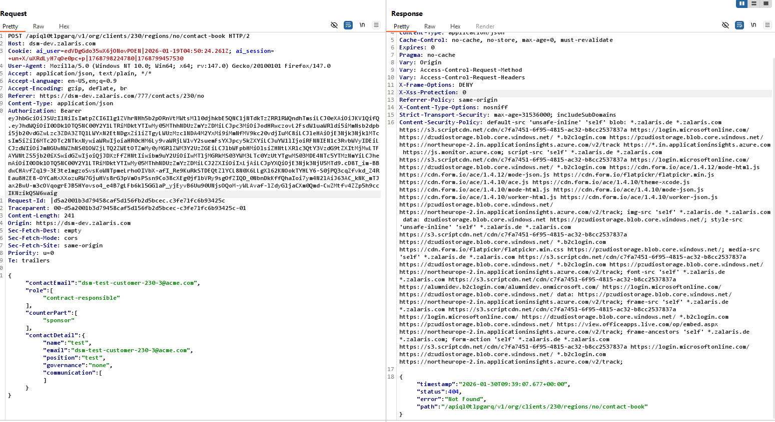
- Refer Screenshot attached below for evidence

The alert is informational as the injected payload is reflected but is not executed as payload

WORKLOG

When | What | Who | Recommended Action
22 January 2026 | Manually Tested Input returned in response (reflected) | CSOC | No Action needed Informational

Browser cross-site scripting filter disabled
Severity | Information
Finding Type | False positive

Issue detail
This issue was found in multiple locations under the reported path.
Issue background
Some browsers, including Internet Explorer, contain built-in filters designed to protect against cross-site scripting (XSS) attacks. Applications can instruct browsers to disable this filter by setting the following response header:

X-XSS-Protection: 0

This behavior does not in itself constitute a vulnerability; in some cases XSS filters may themselves be leveraged to perform attacks against application users. However, in typical situations XSS filters do provide basic protection for application users against some XSS vulnerabilities in applications. The presence of this header should be reviewed to establish whether it affects the application's security posture.

Issue remediation
Review whether the application needs to disable XSS filters. In most cases you can gain the protection provided by XSS filters without the associated risks by using the following response header:

X-XSS-Protection: 1; mode=block

When this header is set, browsers that detect an XSS attack will simply render a blank page instead of attempting to sanitize the injected script. This behavior is considerably less likely to introduce new security issues.

The alert is false positive as the header is obsolete

WORKLOG

When | What | Who | Recommended Action | Action plan
22 January 2026 | Manually tested Browser cross-site scripting filter disabled | CSOC | No Issues Found | No action Needed the alert is considered as false positive

HTML5 storage manipulation (DOM- based)
Severity | Information
Finding Type | False positive

Issue detail
DOM-based vulnerabilities arise when a client-side script reads data from a controllable part of the DOM (for example, the URL) and processes this data in an unsafe way.
HTML5 storage manipulation arises when a script stores controllable data in the HTML5 storage of the web browser (either localStorage or sessionStorage). An attacker may be able to use this behavior to construct a URL that, if visited by another application user, will cause the user's browser to store attacker-controllable data.
This behavior does not in itself constitute a security vulnerability. However, if the application later reads the data back from storage and processes it in an unsafe way, then an attacker may be able to leverage the storage mechanism to deliver other DOM-based attacks, such as cross-site scripting and JavaScript injection.
Burp Suite automatically identifies this issue using dynamic and static code analysis. Static analysis can lead to false positives that are not actually exploitable. If Burp Scanner has not provided any evidence resulting from dynamic analysis, you should review the relevant code and execution paths to determine whether this vulnerability is indeed present, or whether mitigations are in place that would prevent exploitation.
Details

The issue reported is Data is read from location.hash and passed to sessionStorage.setItem.value.
The following value was injected into the source:
#e6ayrmc8s0=e6ayrmc8s0%27%22`'"/e6ayrmc8s0/><e6ayrmc8s0/\>cqoc1t5se9&
The previous value reached the sink as:
[{"item":"{\"time\":\"2026-01-19T05:17:39.319Z\",\"iKey\":\"e7185f49-9734-4f80-ba4c-6b25d0d05abb\",\"name\":\"Microsoft.ApplicationInsights.e7185f4997344f80ba4c6b25d0d05abb.RemoteDependency\",\"tags\":{\"ai.user.id\":\"C2MjBeSvaTB2ERa+TUgGZX\",\"ai.session.id\":\"QZR7FvlocLX4zkpr/ku3Jj\",\"ai.device.id\":\"browser\",\"ai.device.type\":\"Browser\",\"ai.operation.name\":\"///777/invoices//kbcqgoega8%27%22%60'%22/kbcqgoega8/%3E%3Ckbcqgoega8//%3Ex2w5iu37sg&#e6ayrmc8s0=e6ayrmc8s0%27%22`'\\\"/e6ayrmc8s0/><e6ayrmc8s0/\\\\>cqoc1t5se9&\",\"ai.operation.id\":\"d5fcbd2676e240d3b05178e57021a8e9\",\"ai.cloud.role\":\"dsm-webapp\",\"ai.internal.sdkVersion\":\"javascript:3.3.9\"},\"data\":{\"baseType\":\"RemoteDependencyData\",\"baseData\":{\"id\":\"|d5fcbd2676e240d3b05178e57021a8e9.63f05bfaee7f4fbf.\",\"ver\":2,\"name\":\"GET /locales/en/locale.json?v=1.0.1767887535542\",\"resultCode\":\"200\",\"duration\":\"00:00:00.849\",\"success\":true,\"data\":\"GET /locales/en/locale.json?v=1.0.1767887535542\",\"target\":\"dsm-dev.zalaris.com\",\"type\":\"Fetch\",\"properties\":{\"HttpMethod\":\"GET\"},\"measurements\":{}}}}","cnt":0},{"item":"{\"time\":\"2026-01-19T05:17:39.485Z\",\"iKey\":\"e7185f49-9734-4f80-ba4c-6b25d0d05abb\",\"name\":\"Microsoft.ApplicationInsights.e7185f4997344f80ba4c6b25d0d05abb.RemoteDependency\",\"tags\":{\"ai.user.id\":\"C2MjBeSvaTB2ERa+TUgGZX\",\"ai.session.id\":\"QZR7FvlocLX4zkpr/ku3Jj\",\"ai.device.id\":\"browser\",\"ai.device.type\":\"Browser\",\"ai.operation.name\":\"///777/invoices//kbcqgoega8%27%22%60'%22/kbcqgoega8/%3E%3Ckbcqgoega8//%3Ex2w5iu37sg&#e6ayrmc8s0=e6ayrmc8s0%27%22`'\\\"/e6ayrmc8s0/><e6ayrmc8s0/\\\\>cqoc1t5se9&\",\"ai.operation.id\":\"d5fcbd2676e240d3b05178e57021a8e9\",\"ai.cloud.role\":\"dsm-webapp\",\"ai.internal.sdkVersion\":\"javascript:3.3.9\"},\"data\":{\"baseType\":\"RemoteDependencyData\",\"baseData\":{\"id\":\"|d5fcbd2676e240d3b05178e57021a8e9.107b98c4684f4430.\",\"ver\":2,\"name\":\"GET https://alumnidev.b2clogin.com/alumnidev.onmicrosoft.com/b2c_1_dsm/v2.0/.well-known/openid-configuration\",\"resultCode\":\"200\",\"duration\":\"00:00:01.293\",\"success\":true,\"data\":\"GET https://alumnidev.b2clogin.com/alumnidev.onmicrosoft.com/b2c_1_dsm/v2.0/.well-known/openid-configuration\",\"target\":\"alumnidev.b2clogin.com\",\"type\":\"Fetch\",\"properties\":{\"HttpMethod\":\"GET\"},\"measurements\":{}}}}","cnt":0}]

The value is passed on to Microsoft Azure Insights.This is expected application Behavior . The alert is considered as false positive
For the issue Data is read from location.href and passed to sessionStorage.setItem.value.
The following value was injected into the source and reached the sink without any modification:
https://dsm-dev.zalaris.com/777/statistics?eizchquz6k=eizchquz6k%27%22`'"/eizchquz6k/><eizchquz6k/\>t2866yhv83&#eizchquz6k=eizchquz6k%27%22`'"/eizchquz6k/><eizchquz6k/\>t2866yhv83&

The payload passed in the URL does not have any effect on the session or DOM

WORKLOG

When | What | Who | Recommended Action | Action plan
22 January 2026 | Manually tested alert HTML5 Storage Manipulation | CSOC | No Issues Found | No action Needed the alert is considered as false positive

TLS Certificate

Severity | NA
Finding Type | Informational

Description
The following problems were identified with the server's TLS certificate:
- The server's certificate is not valid for the server's hostname.
- The server's certificate is not trusted.
Note: Burp relies on the Java trust store to determine whether certificates are trusted. The Java trust store does not include every root CA certificate that is included within browser trust stores. Burp might incorrectly report that a certificate is not trusted, if a valid root CA certificate is being used that is not included in the Java trust store.
The server presented the following certificate:
Issued to: | support.zalaris.de, *.az.zalaris.de, *.hr-box.zalaris.de, *.int.zalaris.de, *.sk.zalaris.de, *.sv-fr.zalaris.de, *.wwn.zalaris.de, *.zalaris.de
Issued by: | DigiCert Global G2 TLS RSA SHA256 2020 CA1
Valid from: | Wed, 06 Aug 2025 00:00:00 UTC
Valid to: | Mon, 23 Mar 2026 23:59:59 UTC (expires in 2 months and 14 days)

Overall Score
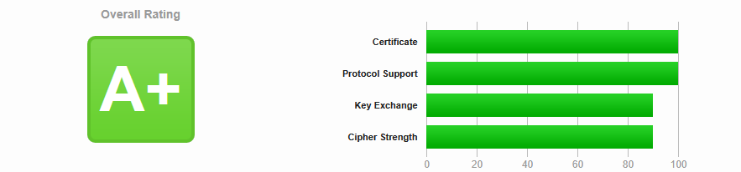
Certificate Validity
SSL/TLS certificate validation confirmed the certificate is active and within its validity period as of the test date
TLS protocols supported

The target supports TLS protocols supported are 1.2 and 1.3 which are considered as secure for current use

Cipher Suites supported

The following cipher suites are used and are secure

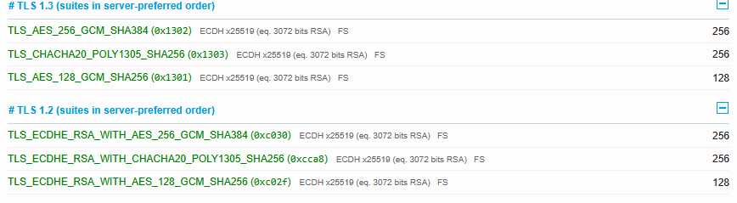
No Issues are found the alert is informational

WORKLOG
When | What | Who | Recommended Action
22 January 2026 | Manually Tested TLS Certificate alert for issues | CSOC | No action needed alert is informational

